**Team Rocket**

CSC 4350: Software Engineering

October 3rd, 2018

Fall 2018

Sydney Adams William K. Holley. IV, Lee Klarich, Jawad Usman

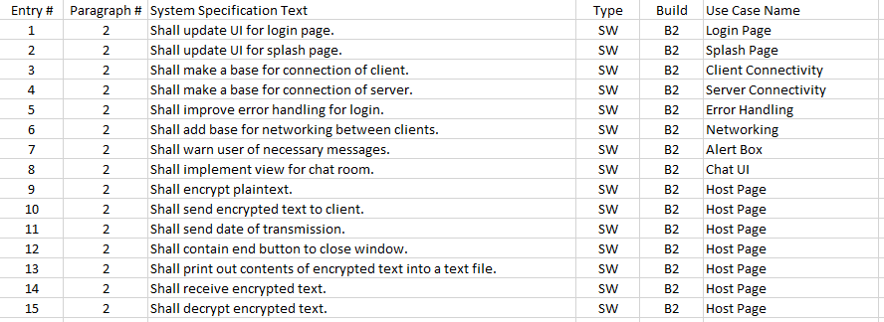The updates for this version of the project are:

* Updated UI for Login Page
* New UI for Splash Page
* Client/Server Connectivity
* Error Handling for Login

User Details: The only working current username is william and the password is holley. Creating an account will also log you in but will not be fed back to the server and make a permanent change.